Screening Tests For Better Health
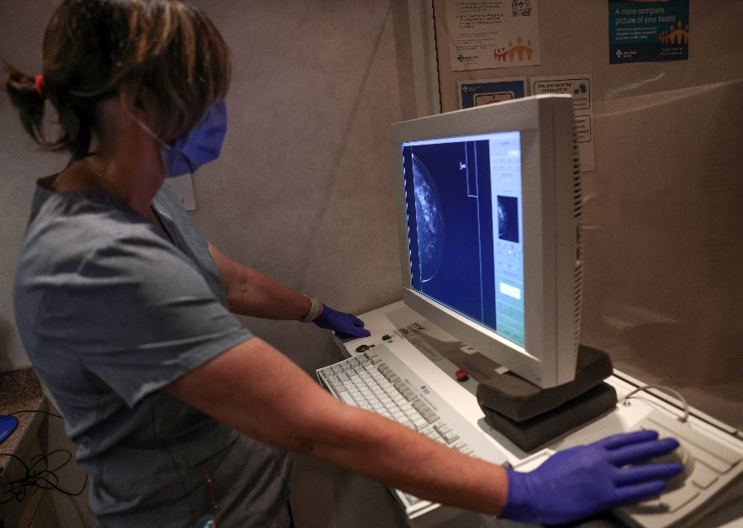
Regular screening tests and checkups can help you stay healthy and are a preventative measure for certain diseases, even before any symptoms appear.
Often, the earlier a disease is diagnosed, the more likely it is that it can be cured or successfully managed. When you treat a disease early, you may be able to prevent or delay problems from the disease. Treating the disease early may also make the disease easier to live with.

What kinds of screening tests are available?
Adults may have several screening tests available to them, such as testing for heart attack, stroke risk, and certain cancers. Your doctor can help you determine the tests you may need and how often to have them.
Visit myhealth.Alberta.ca to find out more about screening tests or by clicking on the links below:
- Abdominal Aortic Aneurysm Screening
- Blood Pressure Screening
- Breast Cancer Screening
- CAGE Questionnaire for Alcohol Problems
- Cervical Cancer Screening
- Colorectal Cancer Test Recommendations
- Depression Screening
- Glaucoma Screening
- HIV Screening
- Osteoporosis Screening
- Prostate Cancer Screening
- Screening for Hearing Problems
- Screening for Weight Problems
- Sexually Transmitted Infection Screening
- Skin Cancer Screening
- Thyroid Screening Recommendations
- Tuberculosis (TB) Screening
- Type 2 Diabetes: Screening for Adults
- Vision Screening and Eye Exams for Adults
- When to Have a Cholesterol Test

How do you decide when to get a screening test?
When and how often you get screening tests may depend on your age, your sex, your health status, and your risk factors. These are things you can discuss with your doctor, and, in some cases, testing is done as part of a routine checkup.
Your doctor may suggest screening tests based on expert guidelines. Sometimes different expert panels make differe3nt recommendations. In these situations, talk with your doctor to decide which guidelines best meet your health needs.
You also may need some screening tests earlier or more often if:
- You have a higher risk for a certain disease, such as diabetes, heart disease, or colon cancer.
- You have a long-term health problem, such as diabetes.
- When you are thinking about getting a screening test, talk with your doctor. Find out about the disease, what the test is like, and how the test may help you or hurt you. You may also want to ask what further testing and follow-up will be needed if a screening test result shows a possible problem.
- Ask your doctor about the limits of the test and treatment. For example:
- Ask your doctor how likely it is that the test would miss a disease (false negative), show something that looks like you have a disease when you don't (false positive), or find a disease that will never cause a problem.
- Ask your doctor about the treatment for the disease that the test looks for. There may be no treatment that helps with symptoms or helps you live longer. In this case, you may decide that you don't want the screening test.
Also think about what you would do if a test shows that you have the disease. For example, if you are going to be tested for osteoporosis, are you willing to take medicine or make lifestyle changes if the test shows that you have it?
Regular screening tests and checkups can help you stay healthy. Talk with your doctor whenever you have concerns about your health.
v

Wellness Articles
Alberta Health Services encourages all Albertans to live a healthy life. These weekly Wellness Articles are created by a team of healthcare professionals from AHS in collaboration with
provincial healthcare experts in Alberta and content from myhealth.alberta.ca.
Our experts ensure this information is factual, current, and written for Albertans.
From stress-relief strategies to finding balance within your life, these Wellness Articles cover a
variety of different topics designed to inspire and educate Albertans on creating a positive and
healthy lifestyle.
We welcome and encourage weekly newspapers, community newsletters and other publications
to reproduce this information free of charge. Please credit Alberta Health Services or the identified
content provider.
If you would like to be added to the distribution list for these articles, please email: rebecca.johnson2@ahs.ca. You will receive a monthly email containing articles for the
upcoming four weeks.

